**Assignment 4**

**Question 1: Graph theory**

1. Let G be a planar graph with at least three vertices. Suppose the drawing is made up of triangles (faces with 3 boundary edges) and faces with 4 boundary edges. There are 10 edges in total. How many triangles do you have and why?

* Atleast 3 vertices
* 10 edges
* Variable amount of faces

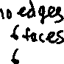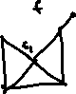

6 faces are possible, one face is the outer boundary. That means 6 triangles are needed, including the outer face.

1. A connected graph has n vertices. How many edges will guarantee that a vertex exists with degree at least 3? How many edges will guarantee that all vertices have degree at least 3?

* Each edge contributes one to the degree of its end points.
* n/2 + 1 edges guarantees that n vertices will be atleast degree 2.
* Odd number of vertices needs an additional edge to link the extra vertex



* To find the minimum number of edges to have a vertex of atleast degree 3, then we must find the minimum number of edges for the entire graph to be degree 2 and add an additional edge.

To guarantee all vertices are atleast degree 3

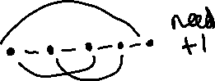

1. How many non-isomorphic graphs are there on 5 vertices such that the graph contains a cycle of length 4? Draw them.

* The graphs would be non-isomorphic based on the number of edges shared by the vertices.

A cycle of length 4 is possible with atleast 4 edges

4 edges:



5 edges



6 edges



7 edges

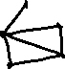

1. A set of n children is such that every child has either 2 friends or 4 friends in the set. A child cannot be friends with him/herself. At recess, the children try to organize themselves into exactly two teams so that each child has all their friends on their team. Explain why no matter how the children divide into two teams, there are always at least 4 children with a friend in the opposite team or no children have a friend on the opposite team.

Every child gets 2 or 4.

* There has to be two teams with children on both teams, not all children can be on one team only.
  + This means two cases
    - Case 1: Two different groups of friends are on the opposing teams
    - No children have a friend on the opposite team
    - Case 2: The groups of friends are put on opposing teams
    - There has to be atleast 4 children with a friend on opposite teams
  + Case 1 can be drawn to represent case 2 with cut-in edges.
* If no children has a friend on the opposite team, it means all children are connected to one cycle.
  + It could also mean two different cycles from two different graphs that aren’t connected.
  + The children are friends in a way such that no two group of friends intersect, then that means there would be two teams with children who are not friends with the children on the other team.
* The second condition is that if there are friends on both teams, then there are atleast 4 children on opposing sides who are friends.
  + This can also mean two graphs which are connected by a cut-edge set which also fulfill the conditions of four children on opposing sides being friends

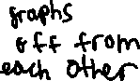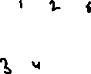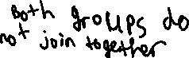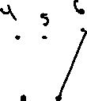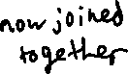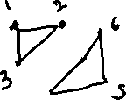

* When there are two distinct group of friends, they can be on opposite teams and still have friends on their side
  + This means no children have a friend on the opposite team
  + This is a scenario where two graphs have cut-in edge between them removed
* However, if we wanted to connect graph 1 and graph 2 together, there is a requirement that the vertices must be of degree 2 or 4
  + This means that one edge between two vertices isn’t enough for graph 1 and graph2 because that would mean one vertex would have an odd number of degrees.
  + That a vertex of degree two requires two additional edges to become a degree four vertex.
    - This means an additional two cut edges to two other vertices from graph 1 to graph 2
    - This has to be done twice because graph 2 would end up with two vertices that are degree 3. An additional cut edge is required for these two vertices on graph 2 to become degree 4
  + A total of 4 cut edges are required between 2 vertices from graph 1 and 2 vertices from graph 2 are necessary to join two teams of children by common friends.
  + This means four children must have a friend on the other side because 4 vertices are the minimum required to connect two different graphs
  + Two pairs of vertices will be connected to 2 vertices on the other graph containing the group of children on the other team

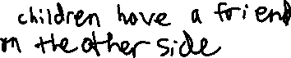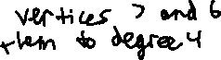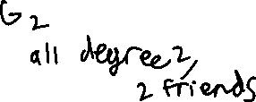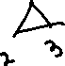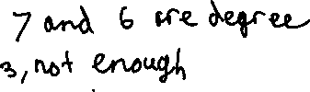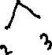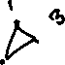

1. A graph consists of 3 connected components, one is C5, and one is K3,4 and one is K4. Explain how many edges you need to add over the whole graph to create an Euler tour. Give an example of a graph for which there is no way to create a Euler tour by adding edges.

* A Euler tour is created when there is a method to traverse all vertices and return to the starting point

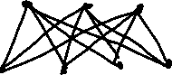

* Above is all three graphs of K(3, 4), a graph of cycle 5, and a K4 graph with the sum of their degrees added up

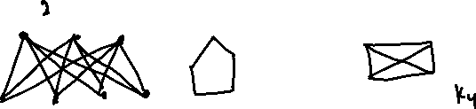

* Two edges are needed to create a Hamilton path
* However, an additional edge is needed to turn the Hamilton Path into a circuit
  + This is because all three graphs need to be connected to each other to form a Hamilton circuit



* A Euler circuit exists if the sum of all degrees is even
* Two edges are necessary to form a Hamilton path
* One additional edge is necessary to form a Hamilton circuit to connect all three graphs together
* A total of three edges is necessary
* The sum of all the degrees of the vertices is still an even number, meaning a Euler circuit is possible

**A graph where a Euler tour is not possible would be the K2 graph**



* In a simple graph, it is not allowed for two vertices to have more than one path to each other.
* If a graph has only two vertices, no more edges can be added
* This has a Hamilton Path, but it is not allowed to add anymore edges, meaning a Hamilton circuit is not possible
* Because a Hamilton Circuit is not possible, a Euler Tour is impossible for this graph

1. A binary tree has 27 vertices. What is the maximum number of leaves? What is the minimum number? Draw the tree in each case. Suppose now that the tree is such that every node has exactly 0 or 2 children. Explain why the maximum number of leaves is the same as the minimum number of leaves in this case. Determine the maximum and minimum height.

* Height is between 4 and 5
* A binary tree with the maximum number of leaves would be a full tree

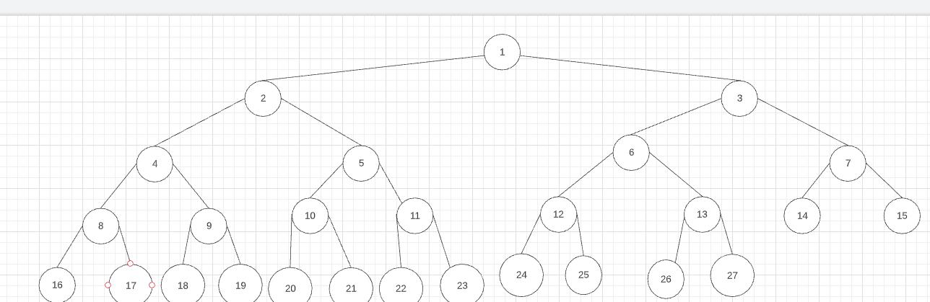

In this nearly complete tree graph, there are 14 leaves in total.

* A binary tree with the minimum number of leaves would be all nodes going one direction

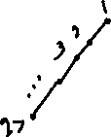

This leaves makes node 27 the only leaf node.

If each parent is supposed to have exactly 0 or 2 children

Minimum:

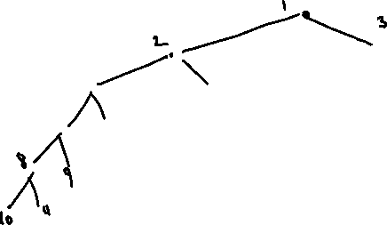

Maximum: Does not change as every node already has 0 or 2 nodes. Remains with 14 leaves.



Minimum height:

The maximum and minimum number of leaves are the same because the binary tree has to be full. This means that for every left or right node being added on, they turn into parents and produce 2 leaves. This means about half of all nodes in a full tree must be parents to hold the other half as leaf nodes.

1. A complete binary tree has height h. Show by induction that the number of leaves in the tree is at most 2h.

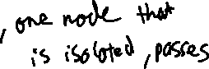

When the height increases by (h+1), that means every child node must be filled with 2 children and the children have to be isolated.

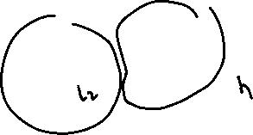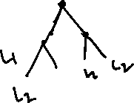

* Whenever the height is incremented by (h+1), that means every leaf node from heigh h must add its own additional leaves.
* Because each parent must spawn 2 leaves to be complete, that means adding 2h for every leaf node already present in h.
* All cases spawn from the base case of the root node spawning two leaves at 20+1

**Probability Theory**

1. One rather dismal afternoon with very little to do, you decide to play a game with your roommate, Celia. Celia rolls a die, and you flip a coin the number of times showing on the die. Your other roommate, Ruth is in the kitchen studying for her math exam. When she comes out you tell her the exciting news that you have flipped a total of 3 heads. Ruth tells you the most likely number that was on Celia’s die. Explain Ruth’s answer

Sample Space: The numbers on the die {3, 4, 5, 6}

* Impossible to roll 3 heads when the die is 1 or 2

|  |  |
| --- | --- |
| Die | Flips |
| 3 | {HHH}, total = 23 |
| 4 | {HHHT, HHTH, HTHH, THHH}, total = 24 |
| 5 | HHHTT, HHTHT, HTHHT, THHHT, HHTTH, HTHTH, THHTH, HTTHH, THTHH, TTHHH, total = 25 |
| 6 | {HHHTTT, HHTHTT, HHTTHT, HHTTTH, HTHHTT, HTHTHT, HTHTTH, HTTHHT, HTTHTH, HTTTHH, THHHHT, THHHTT, THHTHT, THTHHT, THTHTH, THTTHH, TTHHHT, TTHHTH, TTHTHH, TTTHHH}, total = 26 |

**Bernoulli Method**

|  |  |
| --- | --- |
| X | P(X) |
| 1 | 0 |
| 2 | 0 |
| 3 | 1/8 |
| 4 | ¼ |
| 5 | 5/16 |
| 6 | 5/16 |

5- or 6-coin flips gives the highest probability where you would get 3 heads. The probability of this happening is 5/16. Either a dice roll of 5 or a dice roll of 6 gives the same probability for rolling 3 heads.

1. A wedding reception has exactly 2n guests. There are n children and n adults. Each guest writes the name of their preferred dance partners on a piece of paper (allowed more than one!). A couple will dance together if and only if they each chose the other person as their preferred dance partner. For example, if Carol wants to dance with Bob and Bob wants to dance with Carol, then they will dance. Suppose children like to chance with children, so the chance that any child selects another child as a dance partner is 1/2. A child selects any adult as a dance partner with probability 1/10. On the other hand, adults like to dance with adults. The chance that any adult selects another adult as a dance partner is 1/4. The chance that an adult selects a child as a dance partner is only 1/20. Determine the expected number of dances that take place at the reception. Next, repeat the process assuming each guest is only allowed to select exactly one partner. Children will select among all guests equally, and adults will select an adult twice as often as they select a child.



Binomial Theorem: Find A(n) and C(n)

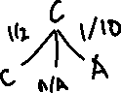

Children:

* ½ chance to choose another child
* 1/10 chance to choose an adult
* 2/5 chance to not choose anybody

Adult:

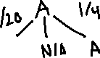

* ¼ chance to dance with another adult
* 1/20 chance to choose a child to dance
* 7/10 chance to choose nobody

Conditional probability based on who selects first

* ¼ chance for adult 1 to choose adult 2
* ¼ chance for adult 2 to choose adult 1 out of n adults
* 1/20 chance for the adult out of n adults to choose the child out of n children
* 1/10 chance for the child to choose the adult out of n adults
* ½ chance for child 1 out of n children to choose child 2 out of n-1 children
* ½ chance for child 2 to choose child 1 out of n-1 children

Now with the conditions that each guest can select only one partner and now children select all guests equally, but adults select other adults twice as often.

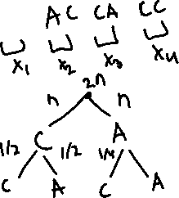

Every guest gets paired with one person specifically, it goes up to n pairs as opposed to n2n-1 where every guest was able to choose as many as he/she would like.

1. Consider a standard shuffled deck of 52 cards. Suppose we draw one card at a time. What is the probability that the second card drawn has the same value as the first? (ex. both are 10s or both are Js). What is the probability that the third card drawn has the same value as the 2nd? What is the expected number of times that we draw two identical cards in a row?

* Draw one card: 52 cards to start with. 13 different cards from each suite.
* Draw a second card, there are 3 other cards that can match that one card out of 51 cards: 1/17

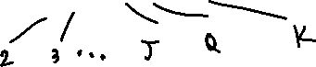

* For two cards to match:
  + A can be any card out of 52: 52/52
  + B must match with A. There are 3 leftover cards that have the same value with A: 3/52 = 1/17 or good draws out of

Probability that a third card drawn will be the same as the second card

* The third card has to match the 2nd card, never mentions having to match the first card. 2 possible events.
* A match with B and C
  + A is any card
  + B must draw from the remaining 3 matching cards with A out of 51 cards: 3/51
  + C must draw from the remaining 2 matching cards with A and B out of 50 cards: 2/50
* A does not match B or C
  + A is any card
  + B can be any card that is not one of the 3 cards that matches with A: 48/51
  + C must match with B where there are 3 matching cards with B: 3/50

Expected number of draws to draw two identical cards in a row (no replacement)

1. Guests arrive at a birthday party one by one. At the entrance, each guest provides their birthday. A guest will receive a $100 prize if his or her birthday is the same as the previous guest. What is the expected number of guests that arrive until the first prize is awarded? What is the expected number of guests that arrive until the second prize is awarded?

The Birthday problem with indicator random variables

* Assuming we can compare only two pairs of guests for their birthdays
* Geometric random variable

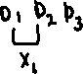

However, the first person will never be able to receive the first prize because he/she is not following anybody

For the second prize:

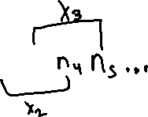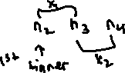

* After the first prize has been won, the process repeats again, using the 1st prize winner as the next person to be compared to for the next guest
* The process is still the same as comparing the birthdays for first prize
  + The person who won the first prize will never be able to win the second prize
  + First prize winner is the same as being the first person to check for the first prize
* Probability would be the same as finding the probability for the first winner, only finding the second occurrence

Requires an additional person because the first person will never be able to win

1. A country has exactly 10 major cities. The government is adding flights between pairs of cities. Suppose the funding allows for exactly 18 bidirectional flights to be added. What is the probability that city A and city B are connected by a flight? What is the probability that one can flight city A to city B to city C? (each a direct flight). What is the expected number of flights out of city A? Suppose now that exactly 5 of those cities apply a tax at their airport. What is the probability that there are exactly 6 flights for which the tax is applied (for all flights)?

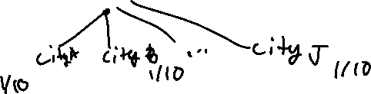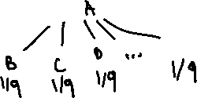

* Each city chooses to fly to one of the other 9 cities, and it can choose to not build a path to any city
  + Assuming bidirectional means City A chooses B and City B must choose A
  + These are both independent choices

Because 1/45 is the probability between two specific cities, this will apply to every probability of a bidirectional flight between two of the 10 cities. 45 different combinations to pair two cities together.

Probability to fly from City A to City B to City C

45 different combinations of pairs between two cities. Can 2 specific pairs between City A, B, and C and leave the rest of the 16 flights go anywhere.

Expected number of flights out of city A

Probability for 6 flights out of 18 to be taxed where 5 cities have been taxed

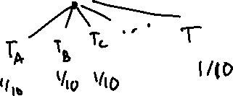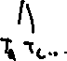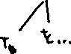

* 2 cases:
  + Start in a city that’s being taxed and fly to any of the 9 other cities
    - Need to fly to 5 other cities that are being taxed
  + Start in a city that’s not being taxed and fly to any of the 9 other cities
    - Need to fly to 6 cities being taxed
  + Because the question is asking for an exact number of flights, binomial random variables can be used where success is getting taxed and no success is not getting taxed.
    - 5 cities being taxed out of 9. 5/9 of flying to a city being taxed
    - 4 cities not being taxed out of 9. 4/9 of flying to a city not being taxed
* Bernoulli Random Variable